Grief and Children: A Handout for Adults

This handout covers the following topics.

What do children and youth do when they grieve?
How can adults help children through the tasks of grief?
When is grieving completed?
What are normal, or typical, symptoms of grief for a child?
What are not typical responses?
What are age-specific grief considerations?
Age 0-2
Age 2-4
Age 4-7
Age 7-11
Age 11-18
What about traumatic deaths?

What do children and youth do when they grieve?
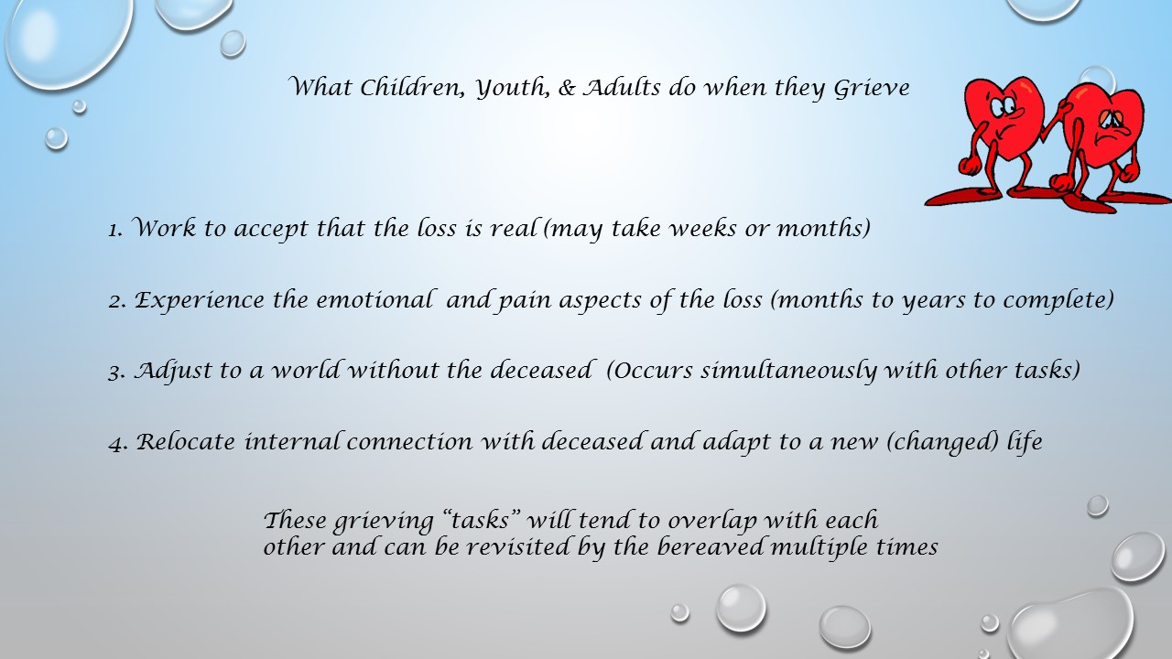

Adults and children accomplish these four tasks as part of the grieving process. The first two phases are generally the most intense. These tasks generally begin immediately after receiving knowledge of the death, or may begin while the loved one is experiencing a terminal illness.

TASK 1: Accepting the reality of the loss. Working on this task facilitates people overcoming the initial shock created by the death. Sometimes people have difficulty truly believing that the deceased is gone, and may find themselves calling for them out of habit, or think that they see them somewhere. This is an intense task that can take weeks or months to complete.

TASK 2: Experience the emotion and pain of the loss. Grief can be thought of as a wound that can be healed. To do that, the bereaved must allow themselves to experience and feel the often intense physical and emotional pain that is associated with the loss. These feelings are often very strong and this task can take months or years to complete. NOTE: If symptoms of depression do not abate after the first month, the bereaved likely needs clinical treatment.

TASK 3: Adjust to world without deceased. The deceased played certain roles or had certain responsibilities prior to their death. These could include anything from particular jobs or chores, to bringing in income, to being a confidant, friend, lover, or simply someone who was generally present in the world of the bereaved at certain times and places. The bereaved must make adjustments and reallocations involving those roles and responsibilities. This task occurs at the same time as the others.

TASK 4: Relocate internal connection with deceased and adapt to a changed life. This task speaks to finding ways to relate to and remember the deceased such that the bereaved can live a changed or new life in a positive and healthy way.

How can adults help children through the tasks of grief?

TASK 1: Accepting the reality of the loss.
Children need to be told the truth in terms they can understand

Some things children tend to do:
- Repeatedly ask questions about the death (may struggle with reality of it)
- May make up stories to fill in gaps in their understanding

Some things parents and teachers can do:
- Allow children to talk freely about the death
- Hold family discussions
- Answer all questions truthfully even when questions are repetitive
- Use developmentally appropriate words about the death, avoid euphemisms
- Include child in the funeral / viewing process – allow them to say goodbye
- Model or demonstrate healthy grieving

TASK 2: Experience the emotion and pain of the loss.
Grief often is expressed physically or behaviorally. Also note that 25% people respond emotionally immediately while 75% generally respond emotionally at a later time.

Some things children tend to do:
- Exhibit combative acting out (show power, hide feelings of powerlessness)
- Overachieve behaviorally; trying to be good or better than usual (may feel bad or responsible for death)
- Withdrawal or become unproductive (expresses powerlessness)
- Have difficulty getting in touch with or expressing feelings (particularly males)

Some things parents and teachers can do:
- Help child express feelings via listening, accepting, caring
- Reassure child that it is not his or her fault
- Reflect back to the child what they are doing or saying
- Be a “Safe Person” to help with expression of feelings
  - SAFE PERSON DO’s: Give undivided attention to child, listen, clarify, validate feelings, reflect a belief in child’s ability to cope, help child brainstorm solutions, honor personal boundaries, keep personal information confidential
  - SAFE PERSON DON’T’s: Discourage or discount child’s feelings, invalidate feelings, give advice, use clichés, reflect incompetency (acting like you don’t know what to do), reflect negative reactions when child is thinking illogically
- Encourage safe physical activity
- Lower expectations for school work temporarily
- Set clear boundaries and expectations
- Consider clinical treatment if child depression symptoms continue after one month after the loss or if any unhealthy responses are exhibited (see below)

TASK 3: Adjust to world without deceased.
Children come to terms with the death in different ways. Active participation in the adjustment process reduces any sense of powerlessness.

Some things children tend to do:
- Respond as if death never happened (allow person to remain “alive” in a sense w/o having to make any adjustments)
- Engage in religious or philosophical rationalizations (try to “get over it”)
- Fill the void with activities or work

Some things parents and teachers can do:
- Encourage or allow children to get some time out from grief via activities or short trips
- Believe the child can recover; Celebrate progress with child
- Discuss changes that are occurring with child and as a family
- Allow child to make adjustments and assume new responsibilities as appropriate (refrain from allowing child to assume any “adult” responsibilities)
- Encourage and celebrate new skills and adjustments that have been made

TASK 4: Relocate internal connection with deceased and adapt to a changed life.
Children do not forget or “give up” the deceased. As they heal they find new ways to relate to the deceased emotionally. Love for the deceased is a feeling that continues long after the death itself.

Some things parents and teachers can do:
- Encourage children in grieving not only recent deaths as they occur but past deaths as well. This helps to stave off symptoms that occur when losses are not completely resolved.

When is grieving completed?
Mourning is finished when the tasks of grieving have been accomplished. This is generally indicated when the child is able to think of the deceased without pain. The child may retain a sense of sadness, but without the wrenching quality it previously had. Remember that children may take as long as 6-8 years to fully complete this process.

What are normal, or typical, symptoms of grief for a child?
Children grieve and re-grieve in a cyclical fashion. They may exhibit symptoms for a while and then not exhibit symptoms for a while. They may re-grieve on a daily, monthly, or yearly basis.

While there is not a hard and fast time limit on ow long grief takes, it is known that children can take 6-8 years to work through the grief process because of the continued development (in terms of cognition) that is necessary to fully process the grief. In general, the earlier a child is in their development, the longer the grieving process may take. However, this time can be shortened with proper assistance.

Normal or Typical Grief Responses in Children and Youth
The following behaviors are typical. Grief reactions will be most intense initially, but generally decline in intensity and frequency over time.

It is typical for a child to have difficulties in these areas:
- School and Learning
  - Have difficulty concentrating
  - Become more apathetic about school work
  - Have some memory loss
  - Be disruptive in class either in an aggressive or humorous way
- Processing Feelings
  - Experience emotional pain (usually expressed through crying)
  - Have problems with anger
  - Seem ok, but be distressed a short time later
  - Become very reflective
  - Talk about the death or the deceased over and over again
  - Dwell on things that used to be enjoyed with the deceased
  - Struggle with loss issues for several years after death
- At Home
  - Difficulty sleeping or eating
  - Difficulty maintaining interest in extra-curricular activities
  - Become concerned about family members
  - Become fearful about the death of other family members

These grief symptoms, while typically declining after being initially intense, are likely to recur on certain anniversaries (birth date, death date, holidays, etc.).

What are not typical responses?
Not all responses represent healthy grieving. Any child exhibiting the following responses should be referred for professional help and treatment, especially if they do not abate after a few weeks.

Unhealthy Grieving Responses
- Major drop in grades and effort
- Symptoms of depression (e.g., apathy, decreased appetite and sleeping difficulties, noticeable weight loss and fatigue, loss of interest in things, social withdrawal, unkempt appearance, etc.)
- Symptoms of severe anxiety or panic disorder
- Suicidal ideation (get help right away!)
- Threats to run away
- Chronic stress-related illnesses, which persist even after a thorough physical exam
- Anger expressed as rage
- Use of drugs or alcohol
- Withdrawal & social isolation from peers and adults

Unresolved Grief
There are times when grief becomes unresolved and pathological. This means that the normal grief process became distorted. Children may experience unresolved grief because their responses are inhibited (they don’t have the developmental capacity to fully grieve), delayed (more common when there is a lot of dysfunction in the child’s family), or chronic (they became stuck in a phase of grief and cannot move forward).

Unresolved Grief Responses
- Excessive expression of intense emotion
- Continued preoccupation (in thought or action) with lost person
- Organizing life as though deceased person is recoverable (like unabated searching behaviors)
- Grieves past losses that were no resolved
- Has a bad temper towards self and friends
- Acts as though they have symptoms of disease that led to the death
- Develops severe depression
- Intense separation anxiety
- Self-destructive behavior
- Has frequent outbursts of anger and bitterness toward inappropriate targets
- Exhibits intense ambivalence
- Idealizes or idolizes the deceased
- Experiences intense reactions on anniversaries (of death, holidays, birthdays, etc.) – this occurs to a lesser degree during normal grieving

What are age-specific grief considerations?
Children will grieve differently as they continue to develop the emotional and cognitive capacity to do so. Reactions listed here, while typical, do not always occur in their entirety. Children grieve in different ways as do adults.

Age 0-2 Years:

Child’s Concept of Death: No cognitive understanding.

Typical Child Responses:
- Feel abandoned
- Intense but brief

How parents and teachers can respond:
- Nurture, rock, hold, talk softly in reassuring tones
- Provide consistent care
- Maintain normal routines as much as possible

Age 2-4 Years:

Child’s Concept of Death: No cognitive understanding; believes death is reversible

Typical Child Responses:
- Intense but brief
- Become difficult to manage during emotional times
- Regress (have accidents if toilet trained, revert to sucking thumb, etc.)
- Have upset stomach or decreased appetite
- Difficulty sleeping
- Ask for deceased repeatedly (particularly if it was someone close like a parent)
- Show little affection or seem very needy of attention

How parents and teachers can respond:
- Be consistent, comforting, reassuring, and nurturing
- Hold, rock, use nurturing touches
- When asked, tell child that the person in question is dead and dead means that the person cannot come back
- Include child to a viewing to say goodbye as long as significant adults can manage this without great shows of distress
  - Allow child to wave to body and say goodbye
- Give child some personal items to help remember deceased

Age 4-7 Years:

Child’s Concept of Death: Sees death as reversible

Typical Child Responses:
- Feel responsible or guilt
- Become preoccupied with what death means
- Repeatedly ask about deceased
- Repeatedly ask questions about death and dying
- Show regression
- Have nightmares or difficulty sleeping
- Exhibit more violent behavior

How parents and teachers can respond:
- Be consistent, comforting, reassuring, and nurturing
- Respond to questions with patience, with the truth, and in simple terms
- Don’t be afraid to admit that you don’t know
- Allow child to come to funeral, but carefully prepare child for experience by describing what will happen before the funeral occurs
- Do not force child to go to funeral if child does not want to go; allow child to visit body privately to say goodbye if desired
- Talk openly about the funeral (keep in mind positive things that child needs to hear)
- Cry and express your feelings about the loss (but reserve any intense expression for when the child is not present)
- Talk about your memories of the deceased
- Read books about death
- Encourage child to draw or tell stories
- Model or demonstrate healthy grieving

Ages 7-11 Years:

Child’s Concept of Death: The child understands that death is permanent. A child closer to 7 years still wants to see death as reversible, but is beginning to understand that it is permanent. The child may view death as a punishment. The child does not have any belief that he/she will die.

Typical Child Responses:
- Experience shock, denial, anxiety, crying, and/or anger
- Will ask many questions about death and its details
- Become preoccupied with morbid questions
- May see death as punishment for past behaviors or have other distorted views
- Become preoccupied with how others are responding to the loss
- Feel different from other children
- Concerned with how peers will treat them when they return to school
- Experience some regression
- Begins to have ability to truly mourn for deceased

How parents and teachers can respond:
- Provide consistency with expectations and routines (healthy food, standard bedtime routines, etc.)
- Provide reassurance and nurturing
- Encourage physical activity
- Be available for child, but allow child to have time alone as well
- Answer all questions honestly and patiently
- Allow child to have choices regarding attending wakes and funerals (unless adults are expected to lose control)
  - If loss of control is expected, allow child to visit with and say goodbye to deceased privately
  - Allow child to choose preferred care-giver responsible for child during funeral
- Encourage expression of feelings
- Read books about death and dying
- Encourage child to draw or talk about feelings
- Model or demonstrate healthy grieving

Ages 11-18 Years:

Child’s Concept of Death: Children understand the permanence of death, that it is final, and will happen to them someday. Children and youth of this age range are developing ability to think abstractly and can begin to process spiritual and meaning-of-life issues.

Typical Child/Youth Reactions:
- Experience a subset of the following: shock, numbness, denial, anger, depression, regression, withdrawal, aggression, relationship difficulties, difficulty concentrating
- React like an adult, but have fewer coping skills
- Wear a mask and appear tough, but be vulnerable and lonely
- Experience depression and anger toward self, deceased, parents, or God
- Repress feelings
- Exhibit noncompliance
- Exhibit regression
- Tend to follow traditional mourning rituals

How parents and teachers can respond:
- Provide consistent guidelines for behavior
- Listen and be available
- Answer all questions honestly
- Involve in funeral planning and activities as much as possible
- Allow child or youth to take a role in the funeral if child desires
- Encourage self-motivation in regard to youth’s funeral involvement; do not micromanage or attempt to take control
- Support expression of feelings
- Encourage support by peers and significant others
- Share books about death, dying, spiritual issues, etc.
- Encourage writing a letter or personal journal regarding feelings and memories
- Encourage child or youth to take responsibility for active involvement in meeting family needs (reduces sense of vulnerability and powerlessness)
- Model or demonstrate healthy grieving

What about traumatic deaths?
Trauma deaths (including those who complete suicides) differ from others because of their suddenness. Typical reactions and responses are enumerated below.

Typical Responses of the Bereaved:
- Time can be experienced differently – moments will seem endless or bereaved will have difficulty recalling entire blocks of time
- May experience shock and numbness; May require medical treatment
- Disbelief may occur; Experience may seem surreal
- If trauma is witnessed, death imprinting (vivid detailed memory of event) may occur. Memories can be re-experienced as flashbacks or nightmares
- Body may physically react to trauma (individual may faint, become hysterical, develop sudden diarrhea or vomiting)
- May become hyper-aroused and have difficulty sleeping, difficulty concentrating, be easily startled, constantly alert
- Limited control of emotions – easily crying, easily angered, severe mood swings (fear to rage)
- Experience severe anxiety or panic attack
- Intrusive thoughts of event (as well as problems from the past, present, or future) may become invasive
- Tendency to move through things (like funerals) with little memory of events
- Tendency to become confused
- Children may personalize experience and feel they are at fault somehow – leads to long-term problems regarding self-esteem and shame.

What Teachers and Parents can do
When a young child experiences trauma, the emotions can be stored without the cognitive ability to describe the experience.
When the body is exposed to trauma, certain biological stress responses occur (increased heartrate, release of adrenaline, release of stored sugars, release of stress hormones, etc.). When traumatic events are re-experienced as flashbacks or dreams, these same biochemical responses occur. Without intervention, the body may begin to break down and post-traumatic stress syndrome (PTSD) can result.

What parents and teachers can do:
- Provide protection and nurturing in quiet environment so that bereaved can process what’s happened
- Encourage child to talk about, draw, or write about event to release the associated emotions
- Assist child to describe the experience
- Help child understand that his or her reactions and experiences are normal for the abnormal situation that occurred
- Contact family members immediately and appropriately
- Young children benefit from such techniques as storytelling, play therapy, and art therapy to allow them to describe feelings and events that he or she does not have the language or cognitive capacity to describe directly.

